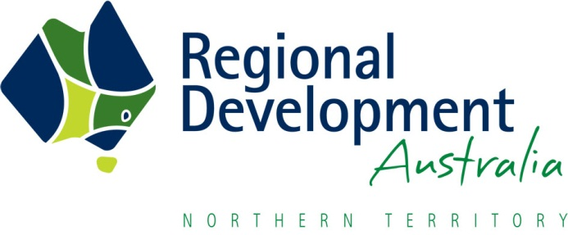

Seeding New Investment Fund
Application Form

Please read the Seeding New Investment Fund Guidelines prior to completing this form.

Project Details
Project Title
Project Summary  (max 300 words) | NOTE: If this application is successful, this project summary will appear on the RDA NT Website.
Project Location (the proposed investment must be in the NT) | You may select multiple box’s:  ☐ Central Australia Region  ☐ Barkly Region  ☐ Big Rivers Region  ☐ East Arnhem Region  ☐ Top End Region (inclusive Maningrida, Wadeye and Tiwi Islands)  ☐ NT wide
Requested Funding  (GST exclusive) | $  NOTE: Funding of up to $50,000 will be awarded. Requests over $50,000 will be considered but will require a significant proponent contribution and will be assessed against a higher return on investment standard.

Project Proponent
Lead Organisation
ABN
Name of Contact
Phone
Email
Relevant previous project experience (max 300 words)
Have you received any public funding for other projects? (max 300 words)
Have you already received any funding to progress this project? (max 300 words)
Do you have any pending / unsuccessful funding applications relating to this project? (max 300 words)
What other sources of funds have you committed to this project? (max 300 words)
Rate the likelihood that this project proceed without Seeding New Investment Fund funding | ☐ Very unlikely  ☐ Unlikely  ☐ Likely  ☐ Very Likely

Project Partners
Partner Organisation 1
Name of Contact
Phone
Email
Partner contribution (max 100 words)

Partner Organisation 2
Name of Contact
Phone
Email
Partner contribution (max 100 words)

NOTE: Please add as many tables as you require to list all the organisations which are partnering with the proponent to deliver this project.

Project Impact & Community Development
Considering the assessment criteria outlined in the Guidelines, provide below or attach as much supporting evidence as you can, including:
- Demonstrated need for the project.
- Project Deliverables – describe the project investment (eg an estimate of the capital costs) and the economic stimulus during construction.
- Project Outcomes – considering the strategic intent of this funding program, describe the community/regional benefit, and the long-term viability and potential spin offs of the project.
- Project Support – provide evidence of community/stakeholder support for the project (eg reference regional plans or organisational priorities, supply letters of support, etc).
- Identify what potential funding sources you will be approaching in order to implement your project (eg Building Better Regions Fund, NAIF, bank loan, etc).

Budget
Income
Proponent Cash Contribution
Proponent In-kind Contribution
Partner Cash Contribution
Partner In-kind Contribution
Funding Sought from the Seeding New Investment Fund
Funding Sought from other sources
(if any)
NOTE: Salaries and administration costs must be included in the in-kind contributions. The Seeding New Investment Fund will assist with consultancy fees and costs associated with external professional services. The Fund will not cover the proponent or project partners operational costs or in-house contributions to progressing the project.

Expenditure
Consultants Fees
Other specialist Service Fees
NOTE: Please provide quotes as evidence of the costs associated with development of the business case or professional documentation. Local procurement is strongly preferred however we understand that some specialist services may need to be sourced from outside the NT, if this is the case please provide justification.

Endorsement of Application
Name
Signature
Date

Submit your completed application and supporting documentation to admin@rdant.com.au by 5pm 1 November 2021.

CONTACT DETAILS
RDA Northern Territory
Email: admin@rdant.com.au
Phone: (08) 8941 7550

